

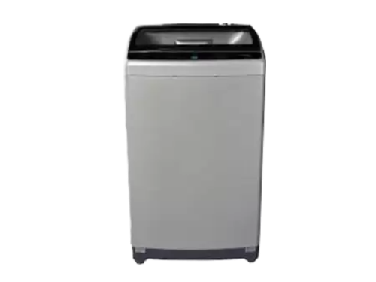

**Haier HWM 150-826 Fully Automatic**

• SKU#:23989

• Item Condition: New

• Stock Info: Available

• Warranty: 1 Year Warranty

• Machine 15Kg